**CCGC 5004 Database Systems**

**Lab Exercise 10 Document Store**

**Overview**

**To receive credit for this lab you must be present in today’s class. Late submissions are deducted 5% per day up to 5 days. Submissions received after 5 days will be given a grade of 0.**

**You will write and execute the required statements as requested in the questions below.**

1. **Open a session to MySQL Workbench**. You will need to download a file from Blackboard in Lesson 11 called world_x.sql script. Place this file on your desktop of your VM after you download it. You will need to run this sql script against your schema that you have in MySQL. After you have run this script, you will have 2 more tables, CITY and COUNTRY, and a document store called COUNTRYINFO. Take a capture of some part of the script to show it has been run. Run the script in MySQL Workbench. (**Screen Capture 1**)

1. Connect to MYSQL Shell or as it sometimes shown mysqlsh. This is the MySQL icon on the right not the left.



This will open a session to mysqlsh.

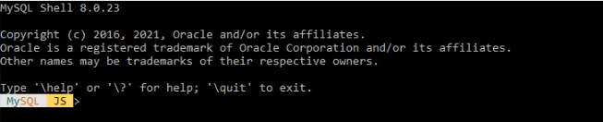

At the prompt you will need to enter a connection string to connect to mysqlsh using the X Plugin for X DevAPI.

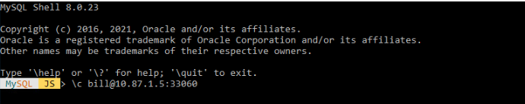

My account name is bill. Yours will be the “N” student number with the F22 appended. The IP address is 10.87.1.5 followed by a colon then the port number of 33060. You will be prompted for your first connection a password. It is the same password you connected with in MySQL Workbench. The initial password was Humb3r22@. Enter this password to connect. You will be asked to save this password for future connections.

Once you are connected the prompt will change to reflect your connection.

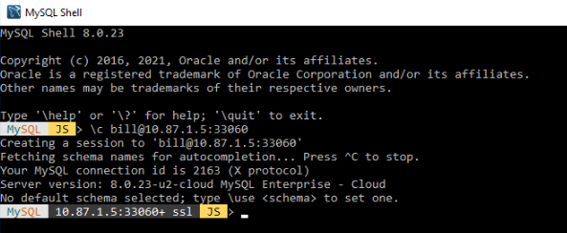

The final step here is to connect to your schema. Ener \use <schema> where schema is your schema name. You will notice the prompt changes to reflect your schema name.

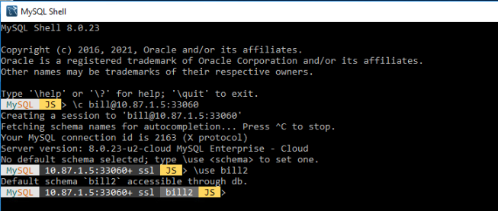

Take a screen capture to show that you are now connected to mysqlsh. (**Screen Capture** **2**.)

1. At the prompt enter db. Show the value that is returned. (**Screen Capture 3**)
2. Switch to the SQL environment. Write a **SELECT** statement that returns just the first 1 row from the categories table, from our previous material. (**Screen Capture 4**)
3. Switch back to the JS environment. Create a new collection called humber. Show the command to create the collection. (**Screen Capture 5**)
4. Display the names of the collections you have in your schema. (**Screen Capture 6**)
5. Write a statement to return details from countryinfo about Canada. (**Screen Capture 7**)
6. Write a statement to return details from countryinfo about the Region of North America. Only return the first 3 records in the document. Sort the records returned so it is alphabetical order. (**Screen Capture 8**)
7. Write a statement to return details from countryinfo about any records where the population is greater than 300,000,000. (**Screen Capture 9**)
8. Rewrite statement 10 to return details from countryinfo about any records where the population is greater than 300,000,000. So, the result will only show the Name and the population. (**Screen Capture 10**)
9. Change the population for United States so it is now 331,200,000. Display the result after you have changed its value. (**Screen Capture 11**) Execute the command you issued for Question 10, to see if the result changes. Show the result. (**Screen Capture 11A)**
10. Add a new record to countryinfo. Use the following information to define this new country:

GNP: 5004

IndepYear: 2021

Name: use your first name

Code: CCGC

demographics

LifeExpectancy: 100

Population: 10

geography

Continent: North America

Region: North America

Surface Area: 100

government

GovernmentForm: Democracy

HeadOfState: your name

(**Screen Capture 12**)

1. Display this new record you added as a single record from your Document Store. (**Screen Capture 13**)